Joining and participating in a webinar (attendee)

Overview
If you are registering or joining a webinar and haven’t received an email confirmation that’s for a panelist or alternative host, you are an attendee in the webinar. As an attendee, you can mute/unmute your audio, virtually raise your hand, and send messages to others.
Note: Some attendee controls won’t be available if disabled by the host. If you have additional controls not shown here, you may be a co-host or panelist in a webinar or an attendee in a meeting.
This article covers:

Prerequisites
- Zoom Desktop Client or Mobile App

Joining a webinar by invitation link
To join the webinar, click the link that the host provided you or that you received in the confirmation page after you registered. If the host sent a registration confirmation email, the link can also be found there.
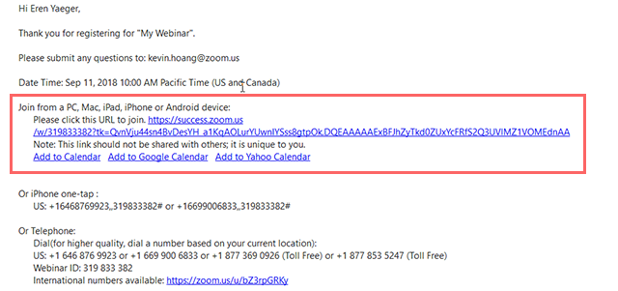
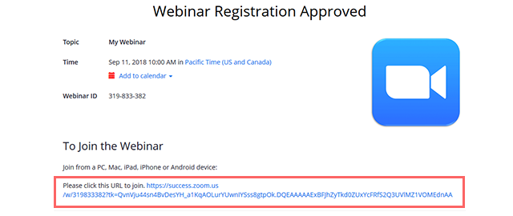

Manually joining a webinar
- Locate the 9-digit meeting ID/webinar ID from your registration email. It may appear at the end of the phone dial-in information, or it will be in the join link, just after https://zoom.us/w/
- Sign in to the Zoom Desktop Client or Mobile App.
- Click or tap Join a Meeting.
- Enter the 9-digit webinar ID, and click Join or tap Join Meeting.
- If prompted, enter your name and email address, then click Join Webinar or tap Join.

Waiting for the host to start the webinar
If the host hasn’t started broadcasting the webinar or is preparing using a practice session, you’ll receive the following message:
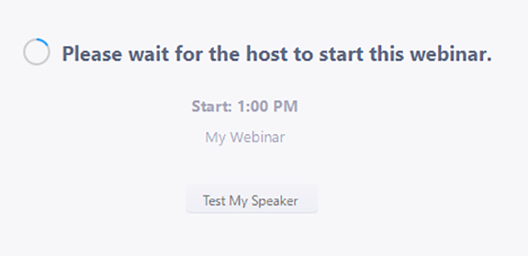
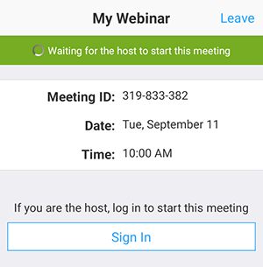
If you receive a message showing the date and time of the webinar, check the the date and start time of the webinar including the timezone. Make sure to join when the webinar starts.
