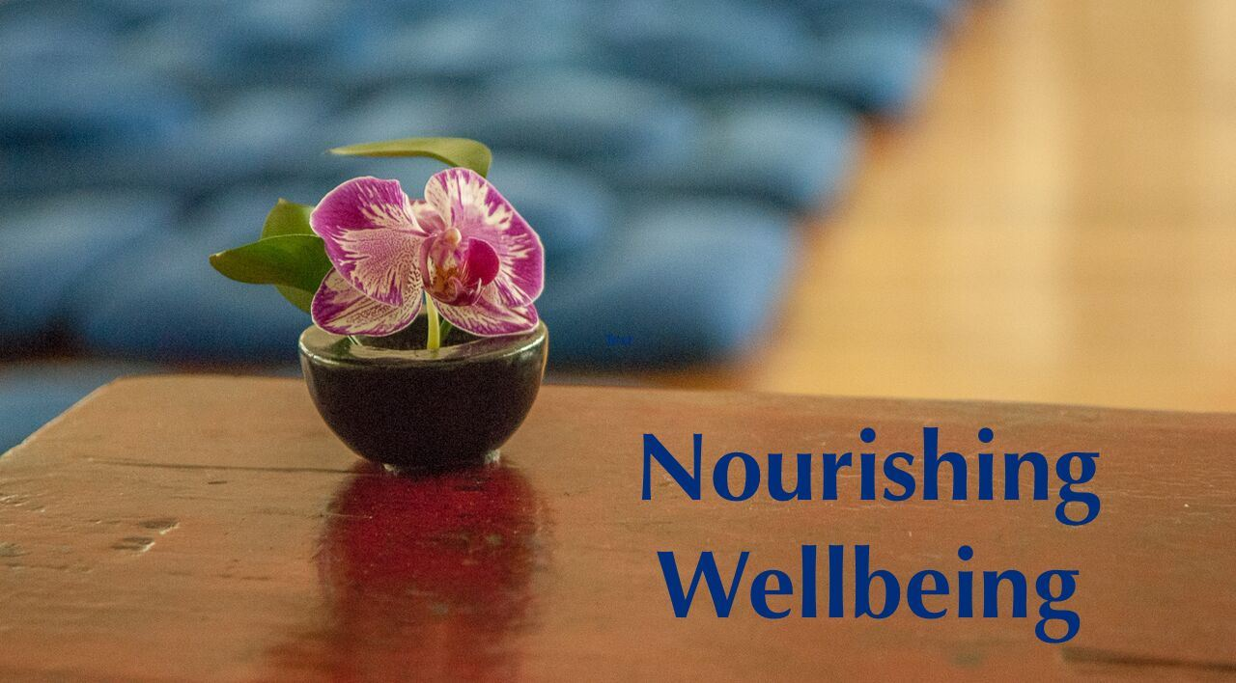

Digital Use Assessment

All of the sensory "food" we consume through our five senses and the conscious mind affects the quality of our lives. From the minute we, awake until we sleep at night, we are seeing, hearing, smelling, tasting, and touching things, and as each sense consciousness encounters an object, a response is triggered. These sensory impressions can feed many things in us, thus it is important that we begin to notice what we are consuming and whether or not it is nourishing wellbeing or ‘ill-being’ within us.

In this digital age, we need to be particularly mindful of how the sensory food of technology is shaping and conditioning our minds. While there is much value and potential with technology, the quantity and quality of our digital use, as well as our relationship to the technology itself, has the potential to create both wholesome and unwholesome effects in our relationships and in our lives. The following Digital Use Assessment has been created to help explore our personal usage and the effects, and if appropriate, to begin a “Digital Detox” process that can help us unplug a bit from technology and plug into non-digital activities that may better support our wellbeing.

The Assessment has two stages. Stage 1 involves keeping a log of digital use and our experience with that use over a two-week period. Once we can objectively view our current behaviors we will be in a position to move to Stage 2, which involves a reflection on the impact of our digital usage on our life and how making changes might bring us more joy, contentment and wellbeing.

May all beings benefit from our efforts to awaken!
Stage 1: Observe
Do we really know whether our use of digital devices is contributing to our wellbeing or perhaps our illbeing? We begin by simply observing what is actually happening in our lives in this area. How much “screen time” do we actually have in a given day? And what are we feeling in our bodies and minds as we reach for, use, and move away from our devices?
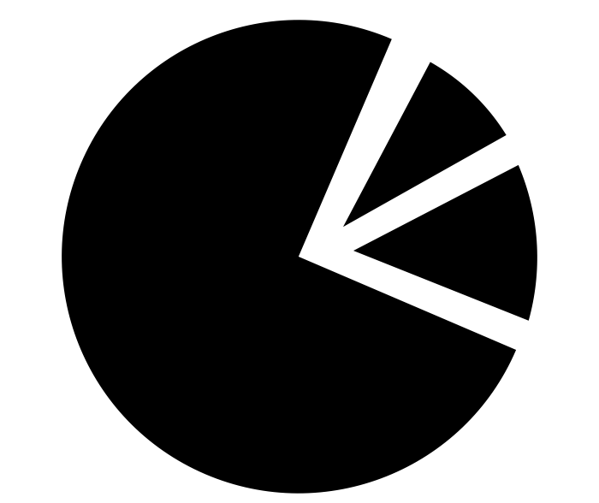
Day 1: Estimate how much time you are currently spending, per day, on your digital devices
Begin by estimating your average daily “screen time” on all devices: smart phone, computer, and notebook, if applicable.

Estimate of Average Daily Screen Time
Personal Use
Email/Texting
Social Media
General Browsing
TV/Video Games
Other
Total Estimate of Personal Use
Work-Related

Days 1 – 7: Log Your Time to Discover Your Actual Usage
For the next 14 days, log each moment that you are on your devices (smart phone, computer, iPad, e.g.) to learn what your actual usage is. There are numerous ways to actually keep a log, as discussed below, but essentially you want to know how many times you are accessing each app and the amount of time spent each time you access it, as well as your total screen time at the end of each day.
One way to log is to keep a small notebook nearby and simply note each time you use an app and the amount of time spent. A simple example of such a log follows. The advantage of this method is that it can be used for all your digital devices, requires no special knowledge or tech skills to use, and is free. The disadvantage is that you need to be extremely diligent in remembering to accurately log each usage of your digital devices.
Another way to log is to use one of the many apps that are available online for this purpose. There are a variety of features and options available. Some apps are only for Android devices, others are for iphones. Most seem to work only on the smart phones whereas (usually for added cost) others may track multiple devices, such as your iphone, ipad and Mac. Most apps will show how many times you were on your device, the duration, and what apps (e.g. email or Facebook) were used in a given day.
Depending on your particular device usage habits and your comfort with technology, you will want to select a method or mix of methods that works best for you. For example, you might load one free app on your phone (“Moment” for the iPhone is shown below), where it may be otherwise challenging to track the many times you check your email or texts during the day. You may then decide to keep a simple log for your computer, find an app that tracks multiple devices, or find a separate app to track computer usage.
A note of caution: our experience in looking at digital tracking apps is that understanding what will work on your particular devices and how to set it up can be a bit complicated and confusing, so don’t hesitate to keep it simple and use the good old fashioned manual notepad if that works best for you.

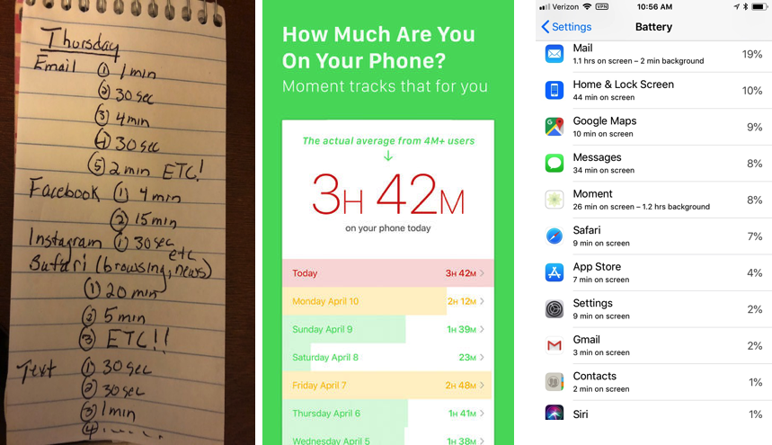

Days 8 – 14: Continue to Log and Begin to Reflect on Your Experience While Using Digital Devices
After a week of observing your digital use, continue logging but now also begin to notice what is being experienced in your mind and body as you engage in digital usage, journaling below.
Tool/Function | What do I notice (e.g. boredom, restlessness, anxiety) in my body and mind as I begin, continue, and stop engaging in this activity?
E M A I L I N G
T E X T I N G
T W E E T I N G
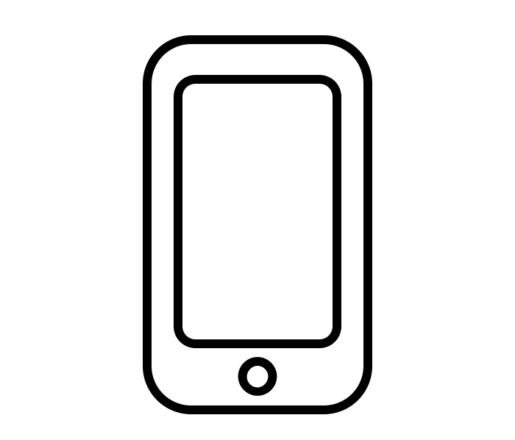
S O C I A L
M E D I A
(e.g. Facebook or Instagram)
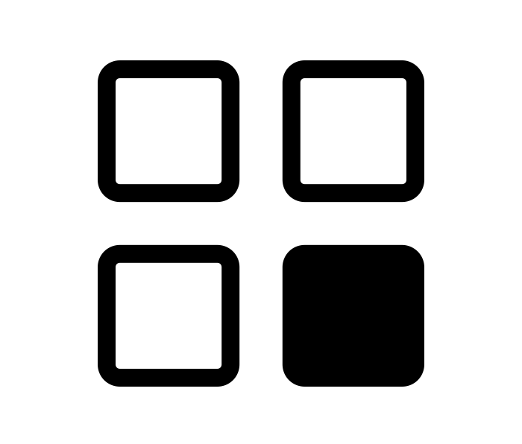

G E N E R A L
B R O W S I N G
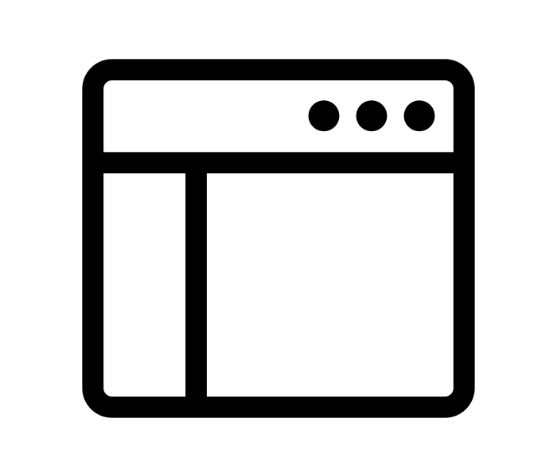

“T V”
(e.g. movies, video games, other)

Stage 2: Reflect
Once you have completed two weeks of logging both usage and experiences while using digital media, please stop to reflect: how is my digital usage affecting my wellbeing. Consider the amount of time spent, the quality of what is consumed in terms of your wellbeing, and your relationship to that particular function (i.e. is there possibly an obsessive and/or compulsive quality?), and journal below. To explore your habits more deeply, please also consider exploring the online resources available at the Center for Internet and Technology Addiction (https://virtual-addiction.com/digital-distraction-test/).

Tool/Function | Is this consumption wholesome for me, i.e. supportive of my aspirations and wellbeing?
E M A I L I N G
T E X T I N G
T W E E T I N G
S O C I A L
M E D I A
(e.g. Facebook or Instagram)
G E N E R A L
B R O W S I N G
“T V”
(e.g. movies, video games, other)

Stage 2: Reflect (cont’d)

By now, you should have a clearer idea of the amount of time you are actually spending on your digital devices, which you may want to record below. Based on your observations above regarding how this use is affecting your wellbeing, are there any changes that might be beneficial to consider?

Actual vs Ideal Daily Hours Spent on …

Actual Average Daily Screen Time | Actual | Ideal
Personal Use
Email/Texting
Social Media
General Browsing
TV/Video Games
Other
Total Personal Use
Work-Related

If you do conclude that it would be beneficial to make changes, what are some steps you might take to replace some portion of your digital use with activities that might better support your wellbeing? For example, you might put limits on the time of day and number of times you look at certain devices, or the amount of time you spend on social media, for example. You might decide to take a walk, have a cup of tea, meditate, call and talk with friends and family, or other activities that better support your wellbeing, instead. What is on your list of aspirations that you are not attending to because of insufficient time or attention? Might you find that time and inspiration when some degree of screen time is reduced? Be creative and enjoy considering how to make changes, no matter how small, that can bring more joy, contentment and wellbeing into your life!

